3.Satellite Subsystems

- Satellite Subsystems

- Attitude and Orbit Control System (AOCS)

- Telemetry, Tracking, Command, and Monitoring

- Power System

3.x Basics of Satellite Communications

  - Communication Subsystems

  - Satellite Antennas

  - Equipment Reliability and Space Qualification

- Satellite Subsystems

A satellite usually has five major subsystems: attitude and orbit control system (AOCS), telemetry, tracking, command, and Monitoring (TTC&M), power system, communication subsystems, and satellite antennas.

Figure 3.1 shows an exploded view of a typical geostationary (GEO) satellite with subsystems indicated.
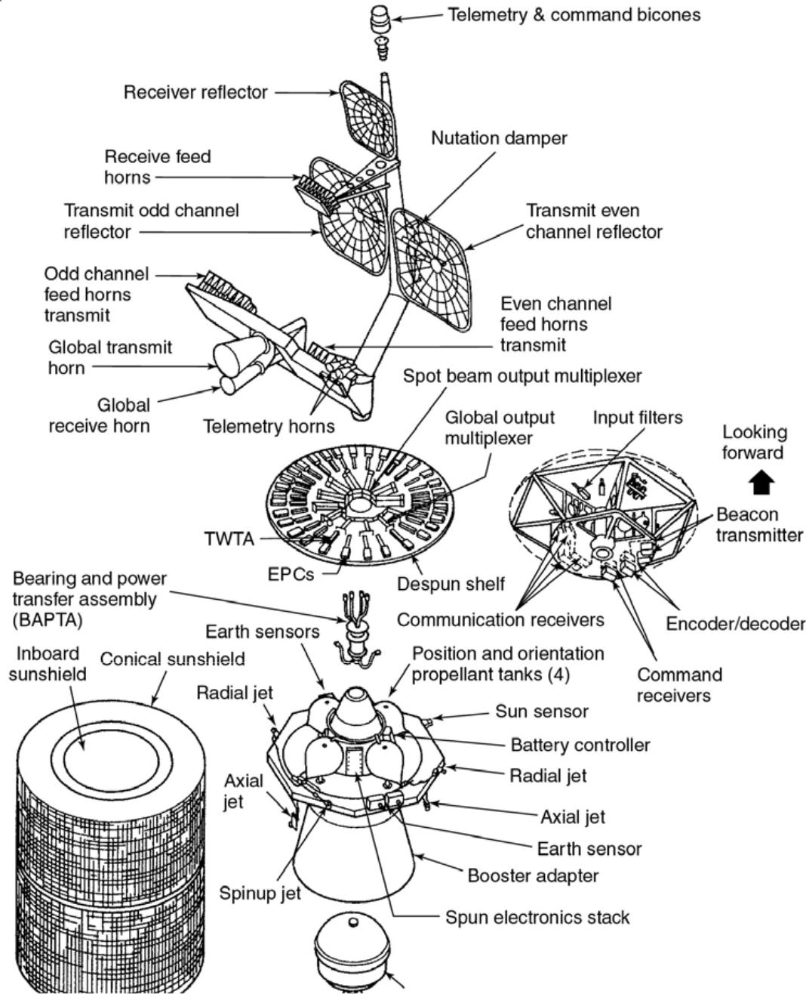

Figure 3.1 Exploded view of a spinner satellite based on the Boeing (Hughes) HS 376 design. INTELSAT IVA (courtesy of Intelsat).

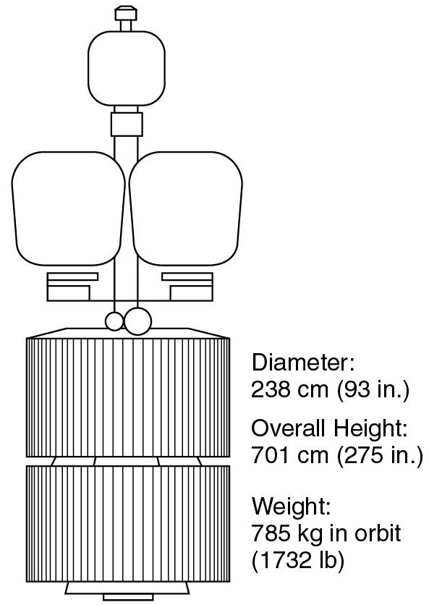

Attitude and Orbit Control System (AOCS)

The AOCS consists of rocket motors to move the satellite back to the correct orbit when external forces cause it to drift and gas jets or internal devices to control the attitude of the satellite.
Telemetry, Tracking, Command, and Monitoring (TTC&M)

The TTC&M system is partly on the satellite and partly at the controlling earth station.

The telemetry system sends data received from sensors on the satellite to monitor the satellite’s health, via telemetry link to the controlling earth station.
The tracking system at the earth station provides information on the range, elevation, and azimuth of the satellite needed in computing orbital elements.
Based on telemetry data received from the satellite through the telemetry system and orbital data obtained from the tracking system, the control system corrects the antenna positioning and communication system configuration to suit current traffic requirements and to operate switches on the satellite.

Power System

Most communication satellites derive their electric power from solar cells.

The power is used by the communication system, mainly in its transmitter, and other electrical systems on the satellite. The latter use is called housekeeping.
Communication Subsystems
The communication subsystem is the major component of a communication satellite, although, frequently, the communication equipment is only a small part of the weight and volume of the whole satellite.It is usually composed of one or more antennas and a set of receivers and transmitters that amplify and retransmit the incoming signal. A receiver-transmitter unit is called as a transponder.

Satellite Antennas

Although antennas form a part of the communication system, they are considered separately from transponders.

On large GEO satellites the antenna systems are very complex and produce beams with shapes carefully tailored to match the areas on the earth’s surface served by the satellite. A satellite which uses multiple frequency bands usually has four or more antennas.
There are other subsystems that are not listed above, but which are essential to the operation of the satellite-the thermal control system that regulates the temperature inside a satellite.
Attitude and Orbit Control System (AOCS)

Control of the attitude of a satellite is necessary so that the antennas, which often have narrow beams, are pointed correctly at the earth.
Gravitational forces from the sun, moon, planets, and planets will set up rotational moments on the satellite if it is not perfectly balanced. Also solar pressure acting on antennas, satellite body, and solar sails may create rotational forces.

The earth’s magnetic field also can produce forces on the satellite if there is net magnetic moment on a satellite. As the satellite moves around the earth, these forces vary cyclically through a 24 -hour period. This tends to cause nutation (a wobble) of the satellite which must be damped out mechanically. The variation in gravitational field causes not only attitude changes but also acceleration on the satellite to change its orbit. The major influence is moon’s gravitational field which is about 3 times (it was twice in Section 2.3) stronger than that of the sun at the geostationary altitudes.
The rate of change of inclination is about 0.86º per year for a satellite initially in a geostationary orbit. If no North-South stationkeeping corrections were applied, the orbit inclination would increase to a maximum of 14.67º from an initial 0º in 26.7 years.
As the earth is not truly spherical, there is a bulge in the equator region of about 65 m at longitudes of 15º W and 165º E, the satellite experiences an acceleration toward a stable point in the geostationary orbit at longitude 105º W and 75º E as shown in below Figure
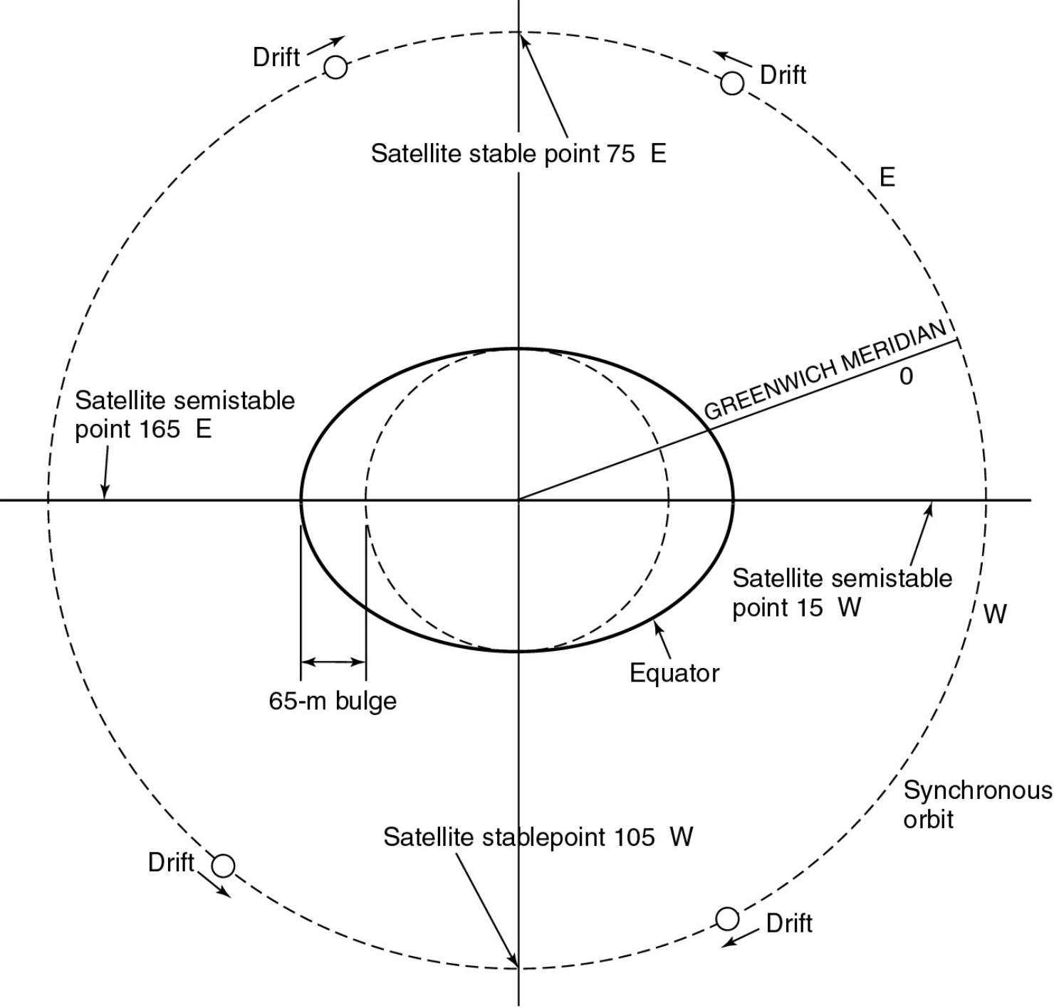

Attitude Control System

There are two ways to make a satellite stable when it is in orbit and weightless: spinning the satellite and using momentum wheels.
The entire body of satellites can be rotated at 30 to 100 rpm to create a gyroscopic force which provides stability of the spin axis and keeps it pointing in the same direction. Such satellites are known as spinners. The Hughes 376 (now Boeing 376) satellite is an example of a spinner design. Alternatively, a satellite can be stabilized by one or more momentum wheels. This is called three-axis stabilized satellite, of which the Hughes (Boeing) 701 series is an example. The momentum wheel is usually a solid metal disk driven by an electrical motor.
Increasing the speed of the momentum wheel causes the satellite to precess in the opposite direction, according the principle of conservation of the angular momentum.

Figure shows the examples of the spinner and three-axis design of satellite.
Figure A spinner satellite, INTELSAT IV Figure A three-axis stabilized satellite,

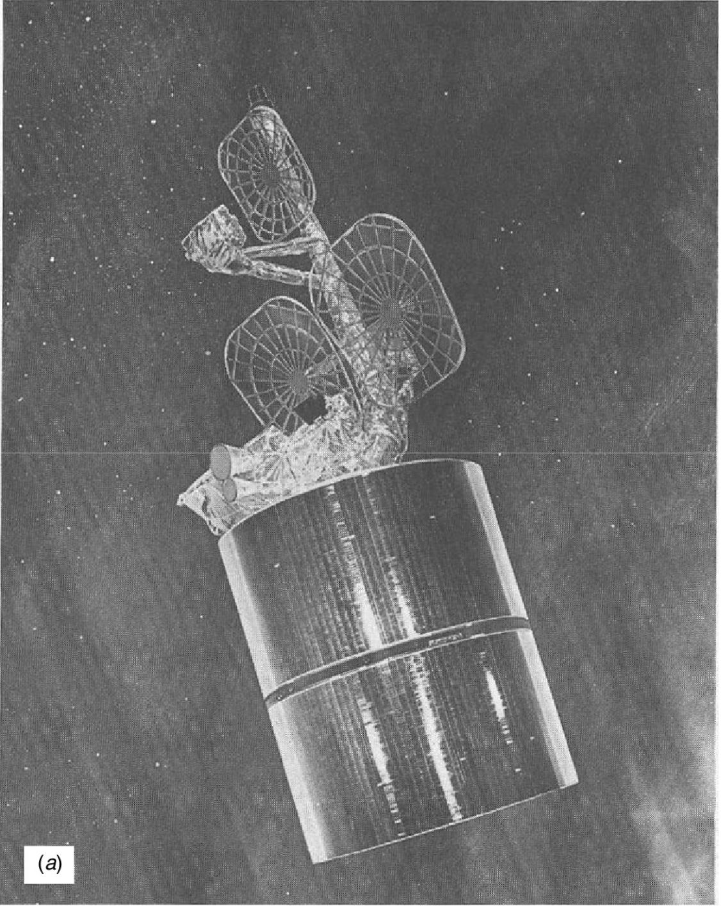
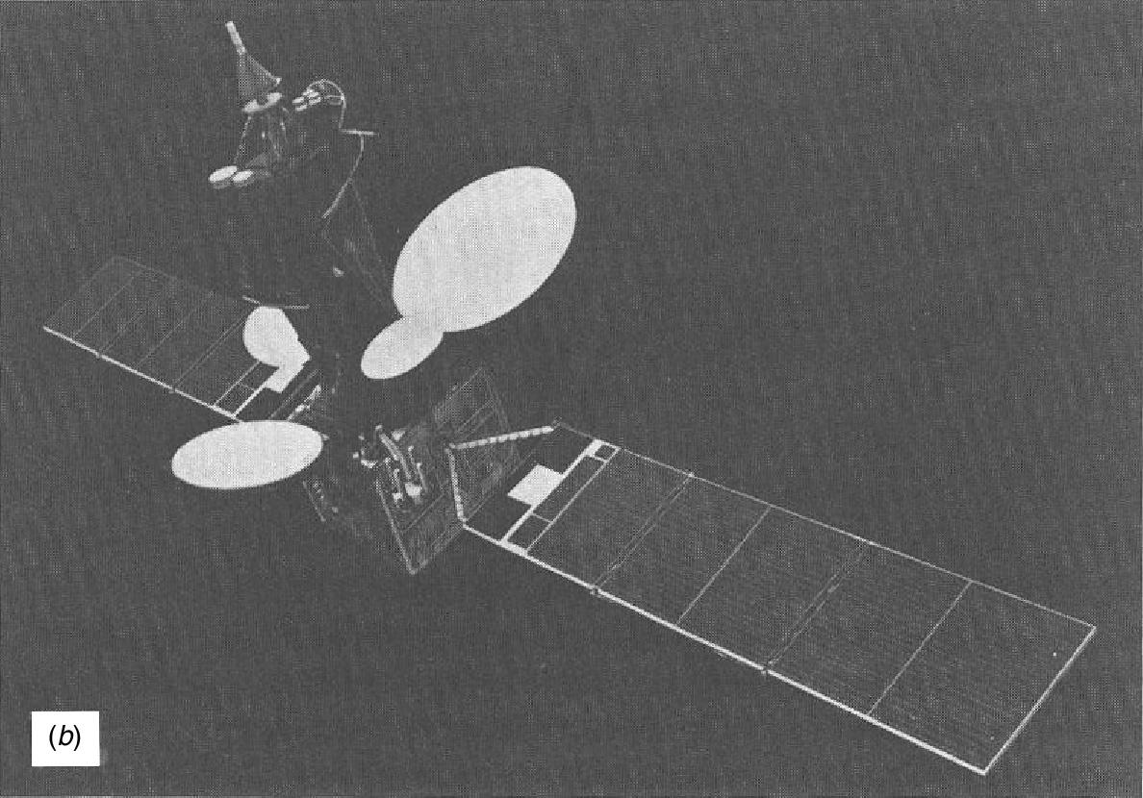

As shown in Figure the spinner consists of a cylindrical drum covered with solar cells that contains the power systems and the rocket motors. The communication system is mounted at the top of the drum and is driven by an electric motor in the opposite direction to the rotation of the satellite body to keep the antennas pointing toward the earth. Such systems are called despun.
At an appropriate point in the launch phase, the satellite is spun up by operating small radial gas jets on the periphery of the drum. Then the despin system operates so that the main TT&C antenna could point toward the earth.
There are two types of rocket motors used on the satellites:
the bipropellant thruster
arc jets or ion thrusters.
The fuel that is stored on a GEO satellite is used for two purposes: to fire the apogee kick motor that injects the satellite into its final orbit, and to maintain the satellite in that orbit over its lifetime.
In the three-axis stabilized satellite, one pair of gas jets is needed foro each axis to provide for rotaion in both directions of pitch, roll, and yaw. With three momentum wheels, rotation of the satellite about each axis can be commanded from the earth station by increasing or decreasing the appropriate of the momentum wheel speed which is called three-axis stabilization. Define a set of reference Cartesian axes ( X _{R} , Y_{R} , Z_{R} ) with the satellite at the origin as shown in Figure
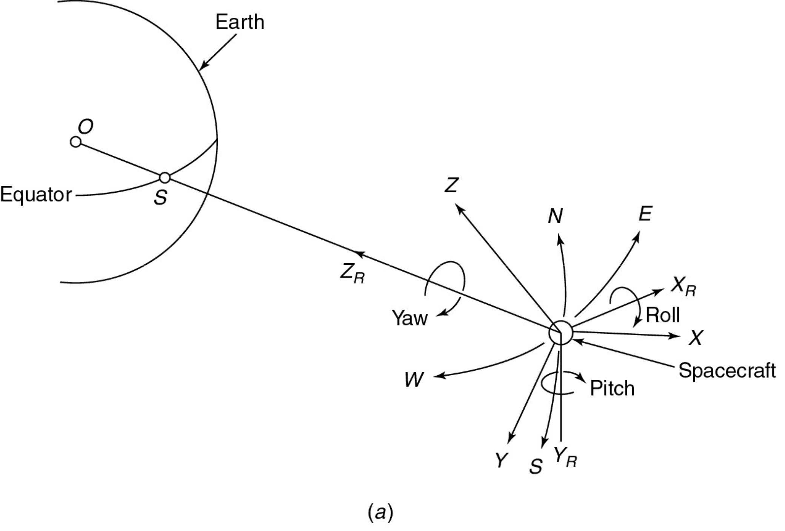
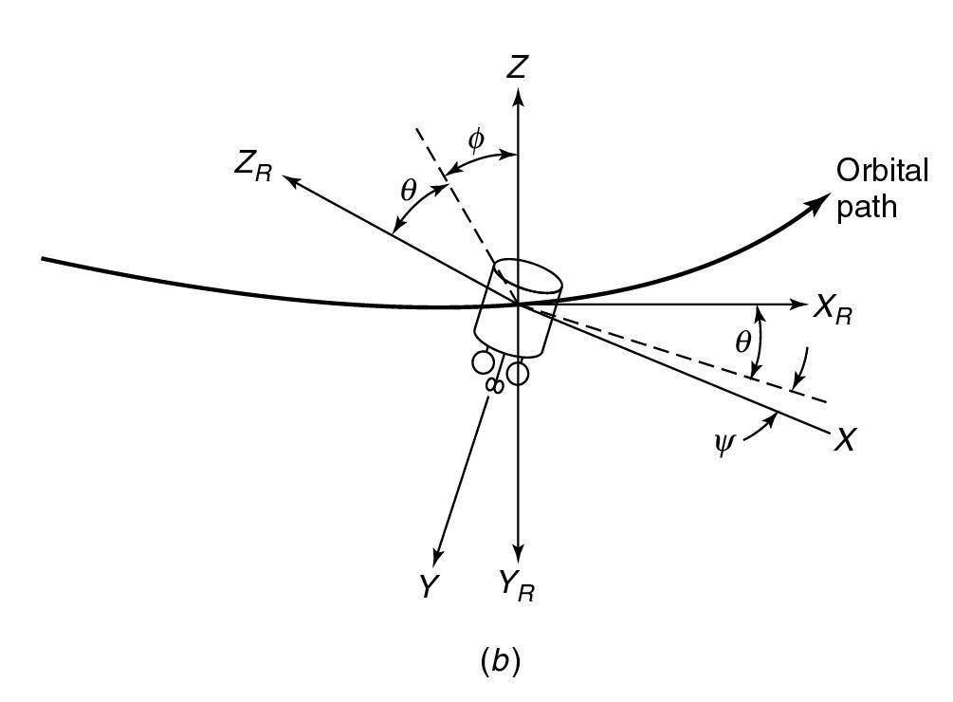

Figure Relationship between axes of a satellite.

The Z_{R} axis is directed toward the center of the earth and lies in the orbital plane.
The X _{R} axis is perpendicular to the Z_{R} axis and lies in the orbital plane.
The Y_{R} axis is perpendicular the orbital plane.

Rotations about three axes are defined: roll about X _{R} , pitch about Y_{R} , and yaw about Z_{R} .

The satellite must be stabilized with respect to the reference axes to maintain accurate pointing of its antenna beams. When large narrow beam antennas are used, the satellite may have to be stabilized within 0.1º on earth axis.
The reference for the attitude control system may be the outer edge of the earth’s disk, as observed with infrared sensors, the sun, or one or more stars.

An infrared sensor on the spinning body of a satellite can be used to N-S control in pointing toward the earth as shown in Figure .
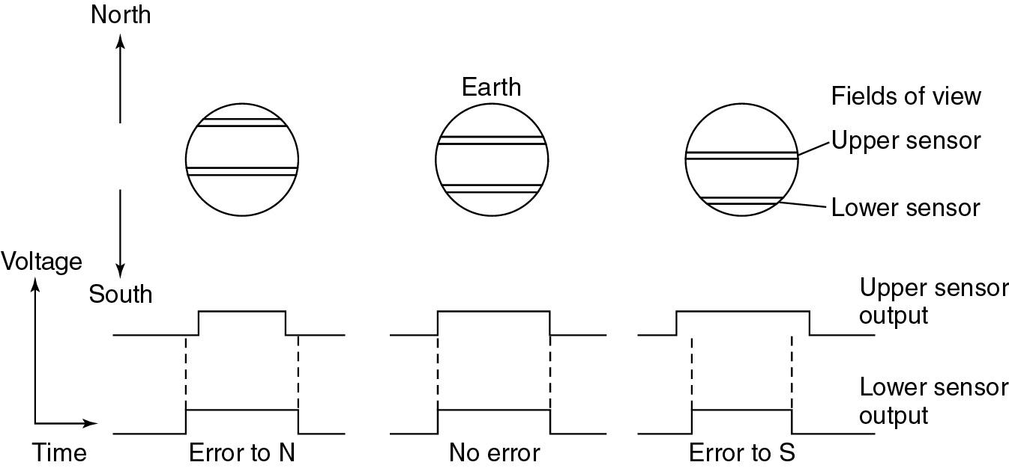

Figure 3.5 Principle of N-S control of a spinner satellite using infrared Earth sensors. Figure 3.6 shows a typical control system loop using the technique shown Figure 3.5.

The control system is more complex for a three-axis stabilized satellite than a spinner.
Figure 3.6 Typical onboard control system for a spinner satellite.
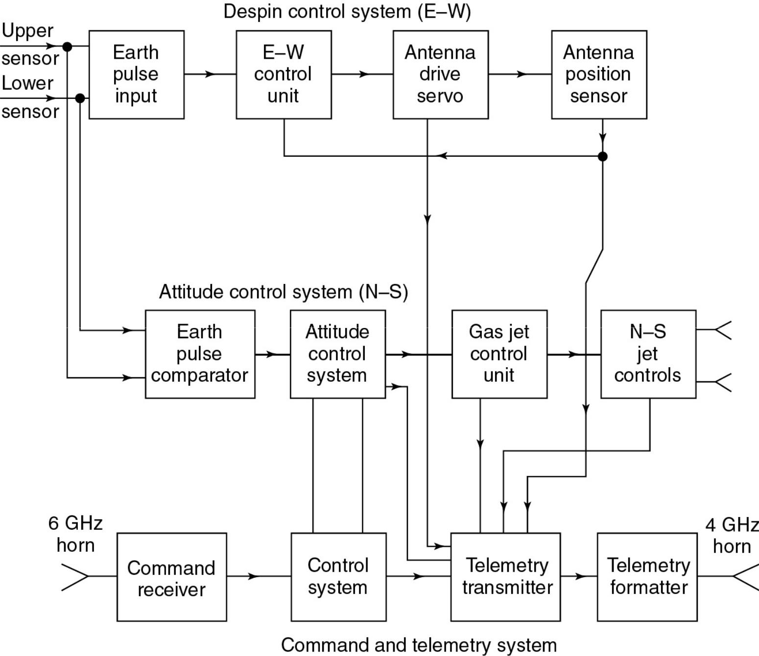

Orbit Control System

A geostationary orbit must be circular at a correct altitude on the equatorial plane.

If the orbit is not circular, velocity change is to be made along the orbit.

For altitude correction, Z -axis gas jet is used.

The inclination of an orbit increases at about 0.85º per year.

Most GEO satellites are specified to remain within in a box of 0.05º and so, in practice, corrections called a north-south station-keeping maneuver are made every 2 to 4 weeks to keep the error small.
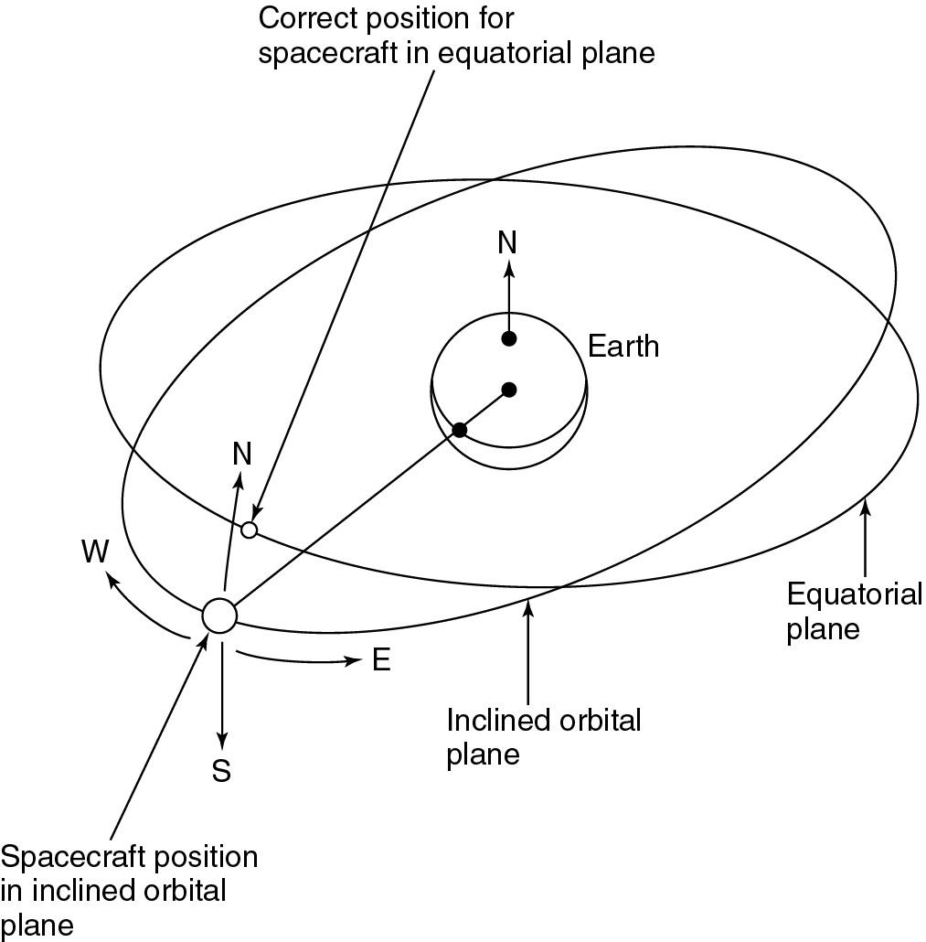
It has become normal to split the E-W and N-S maneuvers so that at intervals of 2 weeks the E-W corrections are made first and then after 2 week, the N-S corrections are made.

East-West station keeping is effective by use of the X -axis jets of the satellite.

Satellite located away from the stable point at 75º E and 252º E, a slow drift toward these points will occur.

East-West station keeping requires only a modest amount of fuel and is necessary on all geostationary communications satellites to maintain the spacing between adjacent satellites.

Some communication satellites such as Russian Molniya series are not in circular geostationary orbit. (Molniya means lightning in Russian.)
Early Molniya satellites were launched into a highly elliptical 12 -h orbit with a large ( 65º ) inclination angle to provide communication to the northerly latitude like Siberia of the USSR. The Russian satellite its name to any satellite in a highly elliptical inclined orbit.
Telemetry, Tracking, Command, and Monitoring

The TT&C system is essential to the successful operation of a communication satellite.

The main functions of satellite management are to control the orbit and attitude of the satellite, monitor the status of all sensors and subsystems on the satellite, and switch on or off sections of the communication system.
On large geostationary satellites, some re-pointing of individual antennas is also possible, under the command of the TT&C system.Tracking is performed primarily by the earth station.

Figure 3.8 shows the functions of a controlling earth station.

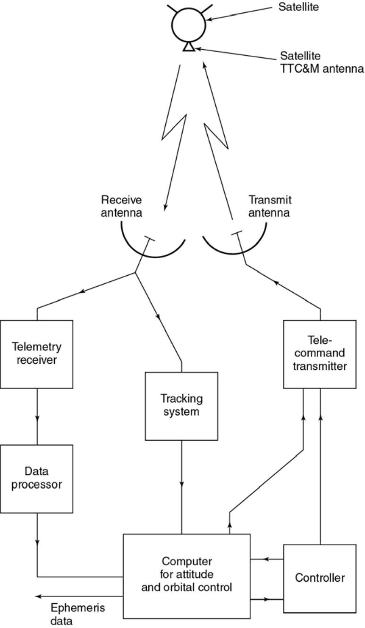

Figure Typical tracking, telemetry, command, and monitoring system.
Telemetry and Monitoring System

The telemetry system at the satellite collects data from many sensors within satellite and sends them to the controlling earth station.
As many as 100 or more sensors monitor pressure on fuel tanks, voltage and current in the power conditioning unit, critical voltage and current in communication electronics, temperature of subsystems, status of subsystems, positions of switches, and sighting device for altitude control.
Telemetry data is usually transmitted as FSK or PSK of low-power telemetry carrier using time division techniques. Low data rate is normally used to allow the earth station receiver to have a narrow bandwidth and thus maintain high carrier-to-noise ratio (CNR). An entire TDM frame may contain thousands of bits of data and take several seconds to transmit.
Tracking

The tracking system at the control earth station provides information about the range, elevation, and azimuth for a satellite. Data from velocity and acceleration sensors on the satellite can be used to establish the change in the orbit from the last known position by integrating data. Doppler shift observation at the control earth station provides the rate of range change.
Active determination of range can be achieved by transmitting pulses to the satellite from the control earth station and measuring its round-trip delay. The position of a satellite can be measured by triangulation from multiple earth stations. The position of a satellite can be determined within 100 m.

Command

A secure and effective command structure is vital to the successful launch and operation of any communication satellite. The command system makes changes the position and attitude of the satellite, controls antenna positioning and communication system configuration, and operates switches at the satellite. During launch it is used to control the firing of the apogee kick motor (AKM) and to spin up a spinner or extend the solar sails of a three-axis stabilization satellite.
The command structure must have safeguards against inadvertent operation of a control due to error. The control code is converted into a command word which is sent in a TDM frame.
After checking for validity in the satellite, the command word is sent back to the control earth station via the telemetry link where it is checked again. If it is received correctly, then an execute instruction is sent to the satellite so that the command is executed. The entire process may take 5 -10 seconds, but minimizes the risk of erroneous commands causing asatellite malfunction.
The command and telemetry links are usually separated from the communication system, although they may operate in the same frequency band (for example, 6 and 4 GHz).
Two levels of command system are used in the Intelsat satellite: the main system operates in the 6-GHz band, in a gap between the communication channel frequencies; the main telemetry system uses a similar gap in the 4 -GHz band.

Figure 3.1 Exploded view of a spinner satellite based on the Boeing (Hughes) HS 376 design. INTELSAT IVA (courtesy of Intelsat).

These are earth-coverage horns, so the main system can be used only after correct attitude of the satellite is achieved.
During the launch phase and injection into geostationary orbit, the main TTC&M system may be inoperable because the satellite does not have correct attitude or has not extended its solar sails. Near omni-directional antenna are used at either UHF or S-band (2 4GHz).
For the back up system, a great deal of redundancy and sufficient margin in SNR at the satellite receiver are allowed to guarantee control under the most adverse conditions.
The backup system provides control of the apogee kick motor, the attitude control system and orbit control thrusters, the solar sail deployment mechanism (if fitted), and power conditioning unit.
It is also used to eject the satellite from the geostaionary orbit and to switch off all transmitters at the end of its useful life.
Power Systems

All communications satellites obtain their electric power from solar cells which convert incident sunlight into electrical energy. Some deep space planetary research spacecrafts have used thermonuclear generators to supply electrical power. But because of the danger to people on the earth in case of launch fail and consequent nuclear spread, communications satellites have not used nuclear generators. Solar radiation falling on a satellite at geostationary orbit has an intensity of 1.39 kW/ m² .
The efficiency of solar cell is typically 20 to 25 % at the beginning of life (BOL), but falls with time due to aging of cells and etching of the surface by micrometeor impacts. Since sufficient power must be available at the end of life (EOL) of the satellite to supply all the systems on board, about 15 % extra area of solar cells is usually provided as an allowance for aging. A spin-stabilized satellite has a cylindrical body covered with solar cells.
Because the cylindrical shape, half of the solar cells are not illuminated at all, and at the edges of the illuminated half, the low angle of incidence of sunlight results in little electric power being generated. Recently a large communication satellite for direct broadcasting generates up to 6 kW from solar power.

A three-axis stabilized satellite can make better use of its solar cell areas than a spinner, since solar sails can be rotated to maintain normal incidence of the sunlight to the cells. Only one-third of the total area of solar cells is needed relative to a spinner, with some saving in weight. With large arrays, a three-axis stabilized satellite can have more than 10 kW of power generated.

In a three-axis stabilized satellite, solar sails must be rotated by an electric motor once every 24 hours to keep the cells in full sunlight. This causes the cells to heat up, typically to 50 to 80º C , which causes a drop in output voltage. In a spinner design, the cells cool down when in shadow and run at 20 to 30 º C , with somewhat higher efficiency than a three-axis stabilized satellite.
The satellite must carry batteries provide power during launch and eclipses. On geostationary orbit, eclipses occur during two periods per year, around the spring and fall equinoxes, with longest duration of about 70 min/day. To avoid the need for large, heavy batteries, a part of communication system load may be shut down during eclipse, but this technique is rarely used when telephony or data traffic is carried. However, TV broadcasting satellites will not carry sufficient battery capacity to supply their high-power transmitters during eclipse, and must shut down during eclipse. By locating the satellite 20º (which is equivalent to 1 hour and 20 minutes) west of the longitude of the service area, the eclipse will occur after 1 a.m. local time for the service area, when shut down is more acceptable.
Batteries are usually of the sealed nickel hydrogen type which do not gas when charging and have good reliability and long life, and can safely discharge to 70 % of their capacity.

Typical battery voltages are 20 to 50 V with capacities of 20 to 100 ampere-hours.

Basics of Satellite Communications
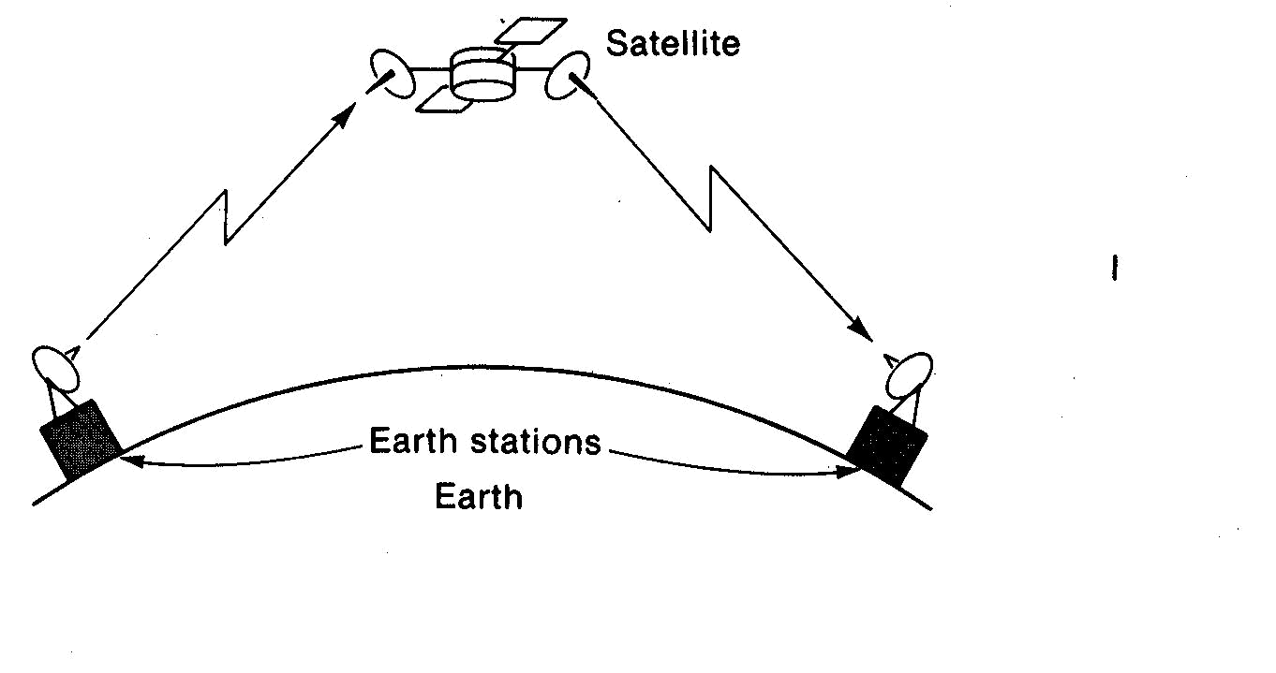
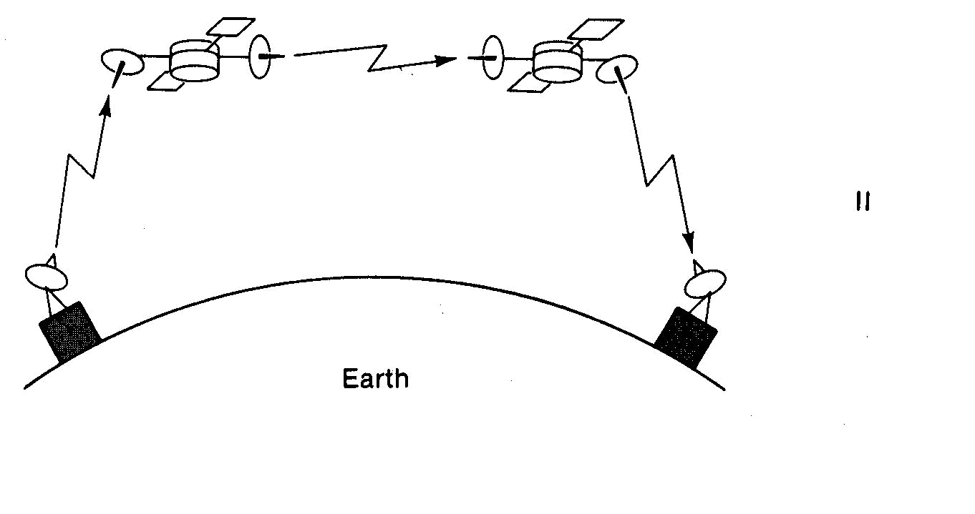
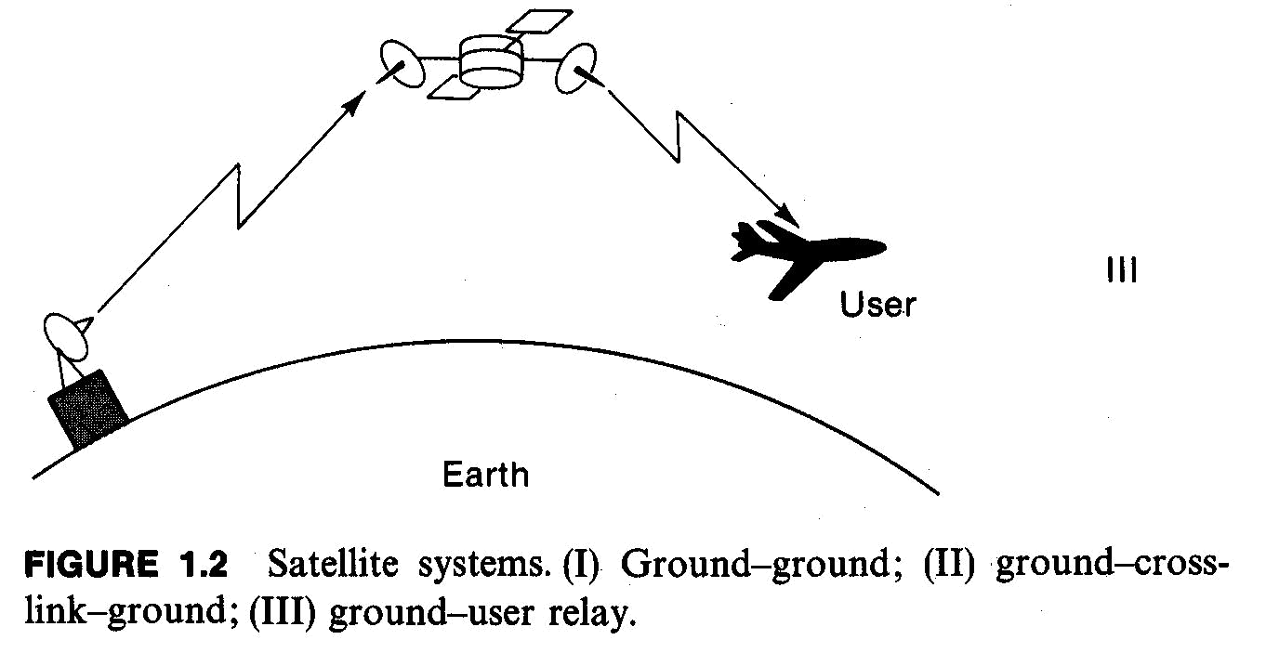

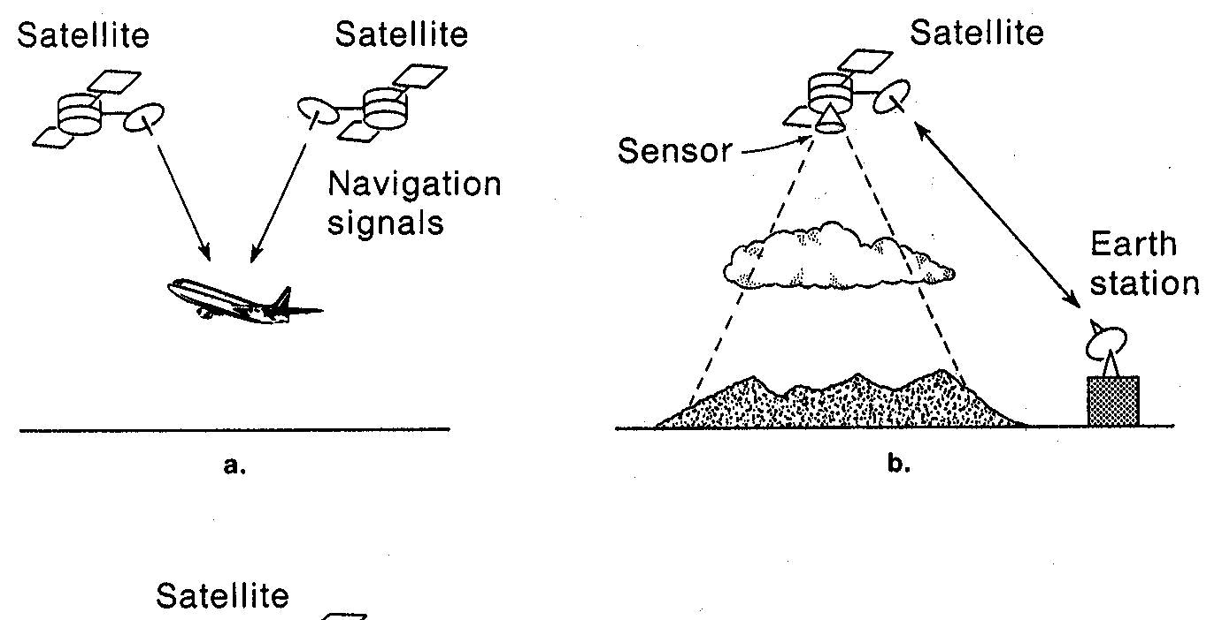
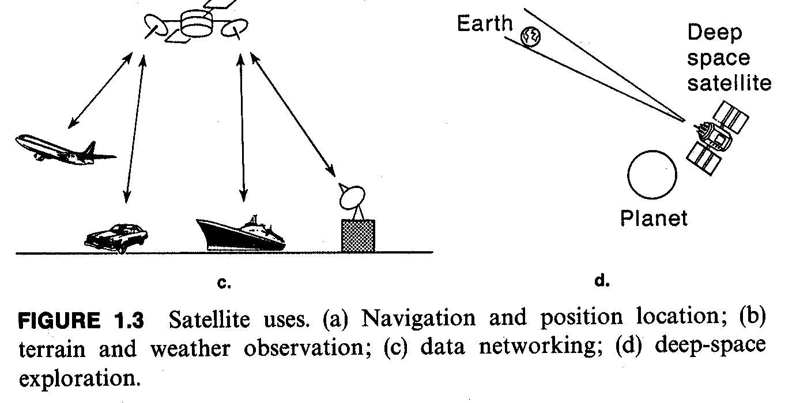
Earth Stations

Earth stations are usually categorized into large and small stations by the size of their radiated power and antennas. Large stations may use antenna dishes as large as 10 60 m in diameter, while smaller stations may use antennas only 3 10 m in diameter, which can be roof-mounted. The current trnd is toward very small aperture terminals (VSATs), using 1 3 ft (0.3 0.9 m) antennas that can be attached to land vehicles or even manpacks. Large stations may often require antenna tracking and pointing subsystems continually to point the satellite during its orbit, thereby ensuring maximum power transmission and reception. The internal electronics of an earth station is generally conceptually simple as shown in Figure 1.4.
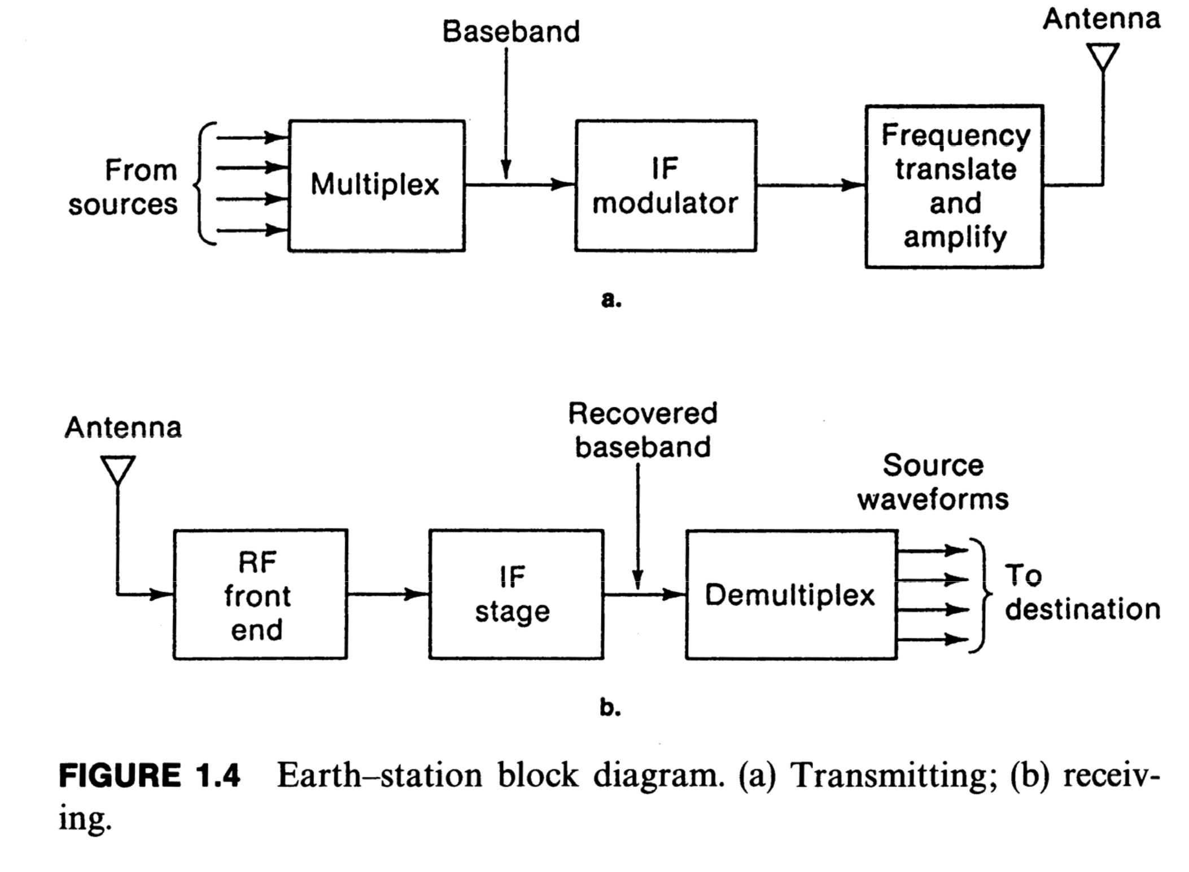

Satellite Multiple Access Format

Fig 1.14 shows multiple accessing satellite links.
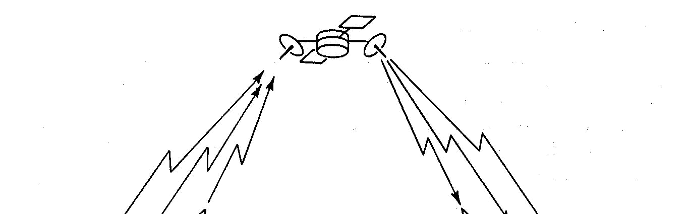
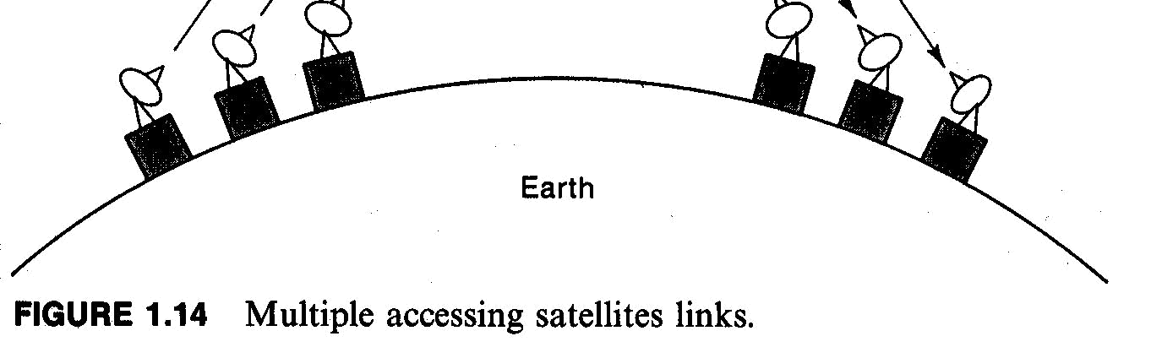

There are basically a few multiple access schemes for satellite communications: FDMA, TDMA, and CDMA.

In a sense it can be said that SDMA (space division multiple access) is also used.
Communication Subsystems

Description of Communication Subsystems

A communication satellite exist to provide a platform in a geostationary orbit for the relaying of voice, and video, and data communications. All other subsystems on the satellite exit to support the communication subsystem, although this may represent a small part of volume, weight, and cost of the satellite. The growth in capacity is well shown in Figure 3.9 for the Intelsat system.
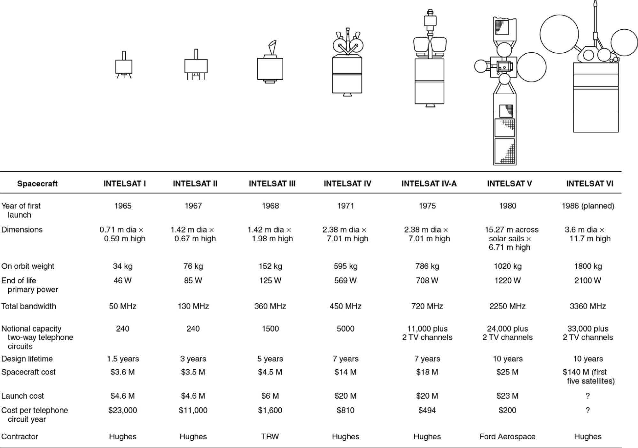

Figure 3.9 Growth in size and weight of Intelsat satellites over three decades

Downlink is most critical part in the design of a satellite communication system. The satellite transmitter has limited power. As link distance is about 36,000 km, the receiver power level is very small and rarely exceeds 10 ¹⁰ W (that is, 70 dBm) even with a large aperture earth station antenna. For satisfactory performance, the signal power must exceed the power of the noise generated in the receiver by 5 - 25 dB depending on the bandwidth of the transmitted signal (which depends on the data rate) and modulation scheme used.

With low power transmitters, narrow receiver bandwidths have to be used to maintain the required SNRs.
Higher power transmitters and satellites with directional antennas enable wider bandwidths to be utilized, increasing the capacity of the satellite. Early communication satellites had transponders of 250 or 500 MHz bandwidth but had low-gain antennas and transmitters of 1 or 2 W output power. When the full bandwidth was used, the earth station could not achieve an adequate SNR because the system was power limited.
Later generations of communication satellites also have been power limited because they could not utilize the RF bandwidth as efficiently as a terrestrial microwave communication system. Their bandwidth utilization efficiency has been steadily improved as shown in Figure 3.9. In high-capacity satellites their available bandwidths have been reused by employing several directional beams at the same frequency (spatial frequency reuse) and orthogonal polarizations at the same frequency (polarization frequency reuse). Some satellites use multiple bands to obtain more bandwidth
Ex.

INTELSAT V achieves an effective bandwidth of 2250 MHz within a 500 MHz at 6/ 4 GHz and 250 MHz at 14/11 GHz by a combination of spatial and polarization frequency reuse.
International agreements restrict the frequencies that may be used for particular services and the regulations are administered by the appropriate agency in each country, for example, the Korea Communications Commission in Korea and the FCC (Federal Communication Commission) in the United States. The WARC (World Administrative radio Conference) makes decisions on changes in frequency allocation.
The standard spacing between GEO satellites was originally 3º , but under regulations covering North America and much of the rest of the world the spacing has been reduced to 2º . The move to 2º spacing opened up extra slots for new satellites in 6/ 4 and 14/11 GHz bands. Narrower spacing for satellite requires earth stations to have narrower transmit beam antennas to avoid interference with adjacent satellites. Higher frequencies make narrower antenna beams and better control of coverage patterns possible. Satellite systems designed for Ku band (14/11 GHz) and Ka band (30 / 20 GHz) have narrower antenna beams and better control of coverage patterns than satellites using C band (6/ 4 GHz). As the available orbital slots for GEO satellite have filled up with satellites using 6/ 4 and 14/11 GHz bands, attentions are focused on the use of the 30 / 20 GHz band.
Originally this band had 3 -GHZ bandwidth allocated to satellite services, but part of the band was reallocated to the Land Multipoint Distribution Service (LMDS). Approximately 2 GHZ of bandwidth is still available for satellite systems at Ka band on an exclusive or shared basis, which is equal to the combined allocations of C and Ku bands. However, propagation in rain becomes a major factor at frequencies above 10 GHz. Attenuation (in dB) in rain increases at roughly the square of the frequency, so at 20 GHz rain attenuation is four times larger in dB than 10 GHz.

Tansponders

Signals (known as carriers) transmitted from an earth station are received at the satellite by either a zone beam or a spot beam antenna. Zone beams receive signals from transmitters anywhere within coverage zone, whereas spot beams have limited coverage. The received signal is often taken to two low-noise amplifiers (LNAs) and is recombined at their output to provide redundancy for traffic. Redundancy is provided wherever the failure of a component will cause the loss of a significant part of the communication capacity of the satellite.

Figure 3.10 shows a block diagram of a satellite communication subsystem for the 6/ 4 GHz band.

In Fig 3.10 “D” stands for the duplexer.
Wireless and Satellite Communications |  | Prof. Jae Hong Lee, SNU
Chapter 3. Satellite | - 53 - | 2nd Semester, 2010
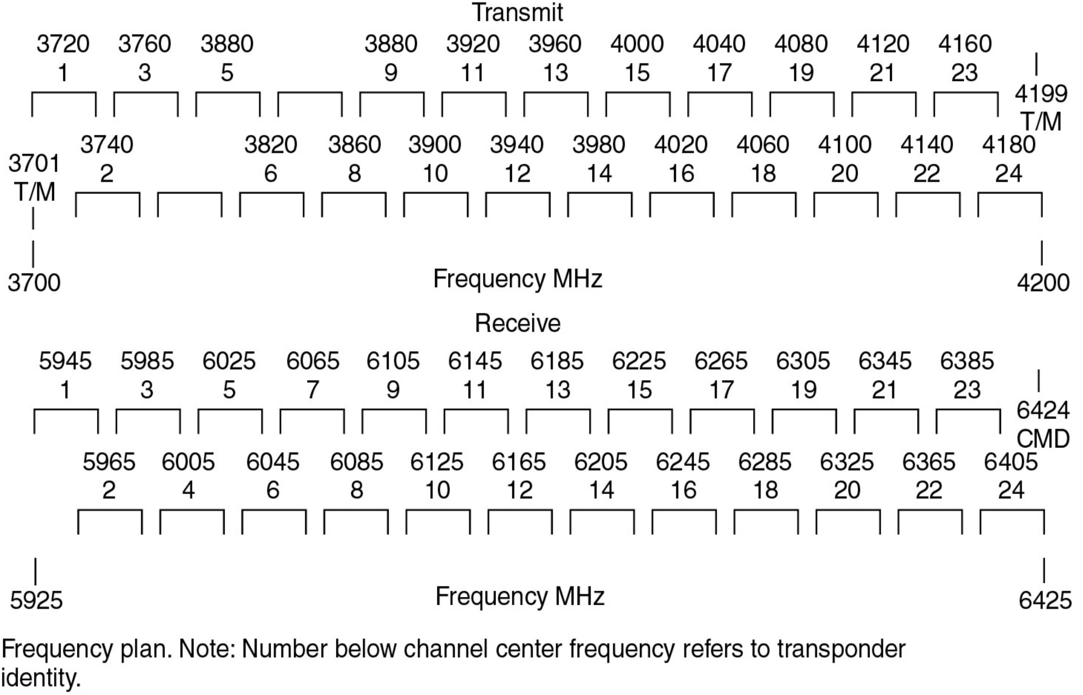
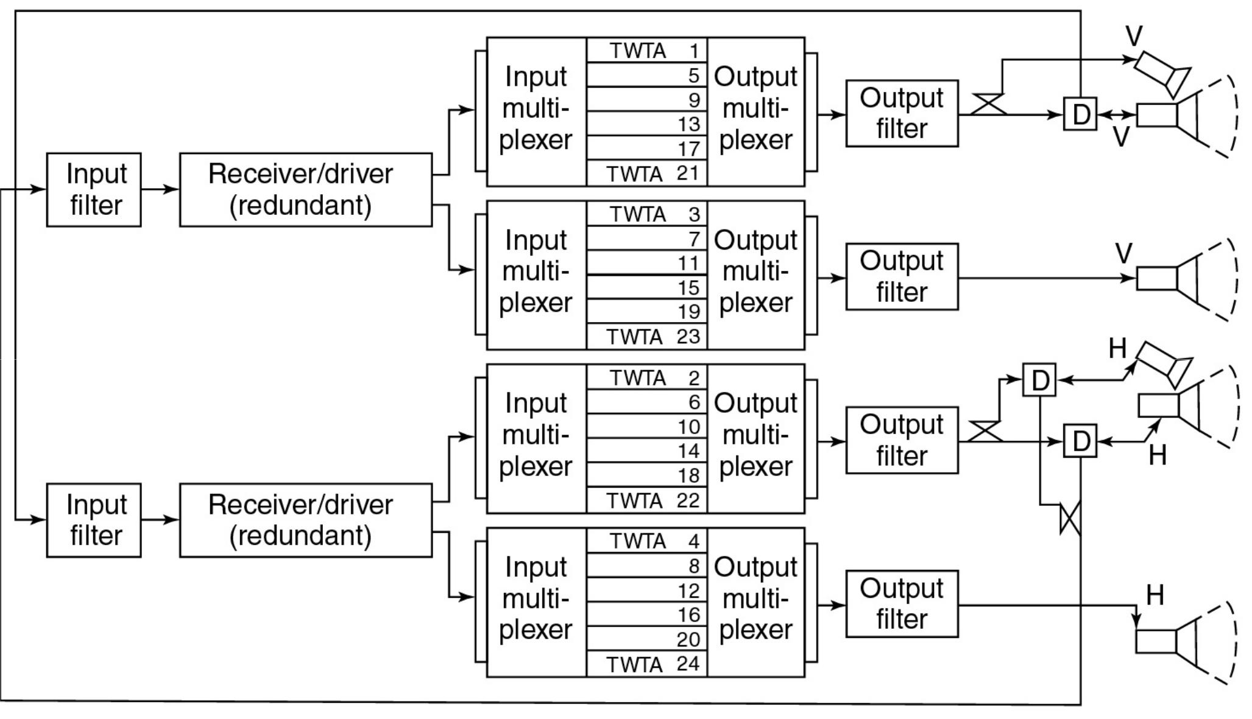

Figure 3.10 Transponder arrangement of RCA’s SATCOM satellites and frequency plan. Translation frequency is 2225 MHz. [From W. H.Braun and J. E. Keigler, “RCA Satellite Networks: High Technology and Low User Cost,”

Proceedings of the IEEE 72, 1483-1505 (November 1984). Copyright © 1984 IEEE.]

500 MHz bandwidth is divided into channels, often 36 or 40 MHz. Each channel is handled by a separate transponder.
A transponder consists of a bandpass filter to select the particular channel’s frequency band, a down converter to change the frequency from 6 GHz at the input to 4 GHz at the output, and an output amplifier.

The communication system has many corresponders, some of which may be spares: typically 12 to 44 active transponders are carried by a high-capacity satellite. The transponders are supplied signals from one or more receive antennas and send their outputs to a switch matrix that directs each transponder frequency band to the appropriate antenna or antenna beam. In a large satellite such as INTELSAT V, there are 4 5 beams to which any transponder can be connected. The switch setting can be controlled from the control earth station to allow reallocation of the transponders between the downlink beams as traffic pattern changes. In the early satellite such as INTELSAT I and II, one or two 250 MHZ bandwidth transponders were employed. Later GEO satellites have used up to 44 transponders each with 36,54, or 72 MHz bandwidth.
The reason for using narrow bandwidth transponders is to avoid excessive intermodulation when transmitting several carriers simultaneously with nonlinear traveling wave tube transmitter. Intermodulation distortion is likely to occur whenever a high power amplifier is driven close to saturation. When a large number of signals share a nonlinear amplifier, a great many unwanted intermodulation products are generated, some of which fall within the transponder passband. (Usually the intermodulation products are not intelligible signals, but they do increase the overall noise level and thus the (C/N) of the wanted signals at the receiving earth stations.)
Intermodulation distortion occurs whenever traveling wave tube amplifiers (TWTAs) are used as wideband amplifiers for more than one signals which drive the amplifiers into saturation. Since more than one earth station transmitters send signals via a satellite, one solution is to provide one transponder for each earth station’s signal.
In the Intelsat system, this could result in a requirement for as many as 100 transponders per satellite.As a compromise between one transponder per earth station and one transponder for all earth station, 36 MHz has been widely used for transponder bandwidth, with 54 and 72 MHz adopted for some satellites. Many domestic satellites operating in the 6 / 4 GHz band carry 24 active transponders.
The center frequencies of the transponders are spaced 40 MHz apart, to allow guard bands for the 36 MHz filter skirts. With total of 500 MHz available, a single polarization satellite can accommodate 12 transponders across the band. When frequency reuse by orthogonal polarization is adopted, 24 transponders can be accommodated in the same 500 MHz bandwidth.

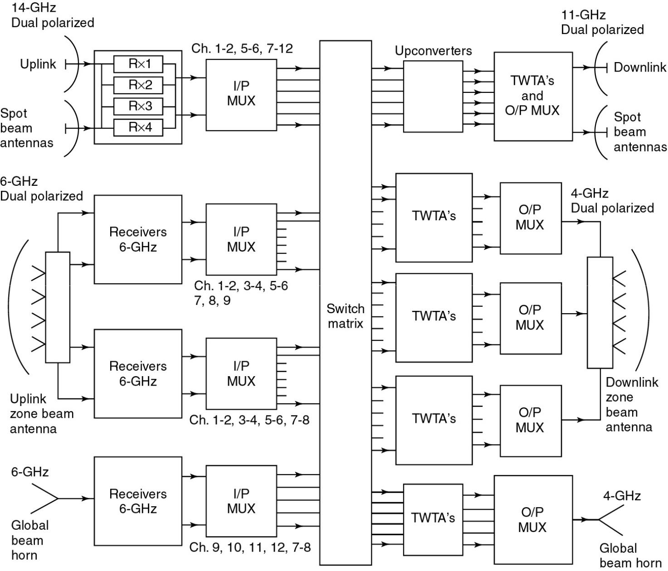

Figure 3.11 Simplified block diagram of an INTELSAT V communication system. (Courtesy C. F. Hoeber, Ford Aerospace and Communications Corp.)

Note that the switch matrix allows a very large number of variation in connecting the 6 -GHz receivers to the 4 -GHz transmitters, and also interconnects the 6 / 4 and 14/11 sections, which provides Intelsats with a great deal of flexibility in setting uplinks through the satellite.

When more than one signal shares a transponder (using frequency division multiple access, FDMA) the power amplifier must be run below its maximum output power to maintain linearity and reduce
intermodulation.

The degree to which the transmitter output power is reduced below its peak output is known as output backoff: in FDMA systems, 2 to 7 dB of output backoff is typically used, depending on the number of accesses to the transponder and the extent to which the characteristics of the HPA have been linearized.

Backoff results in a lower downlink carrier-to-noise ratio at the earth station with FDMA when multiple accesses to each transponder are required.

Figure 6.5 shows the typical input-output characteristic of a transponder using a traveling wave tube amplifier (TWTA).
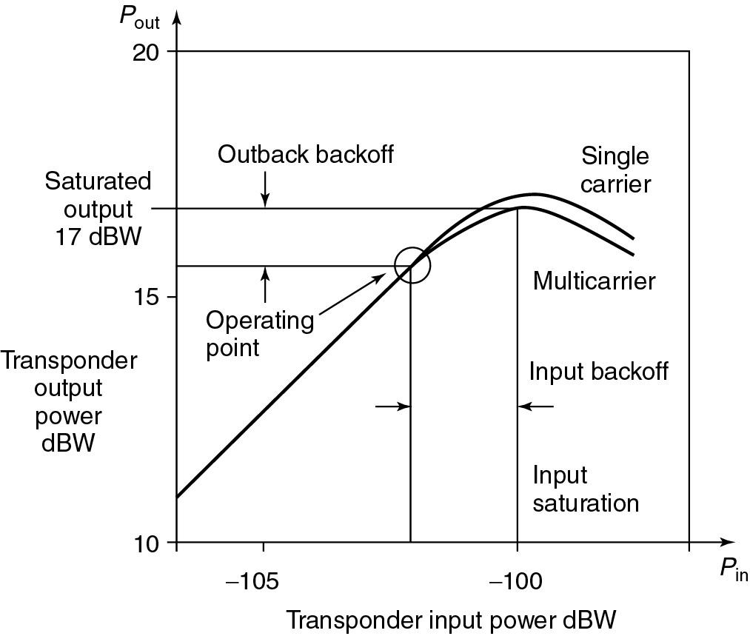

Figure 6.5 Typical input-output characteristic of a transponder using a traveling wave tube amplifier (TWTA).

Notice that the saturated output power is slightly lower with multiple carriers because some output power is converted to intermodulation products.

Time division multiple access (TDMA) can theoretically be used to increase the output power of transponders by limiting the transponder to a single access.

However, most TDMA systems are hybrid FDMA-TDMA schemes known as multifrequency TDMA (MF-TDMA), in which several TDMA signals share the transponder bandwidth using FDMA.

Linearity of the HPA remain an issue for MF-TDMA systems.

Figure 3.12 shows a typical single conversion bent pipe transponder of the type used on many satellites for the 6 / 4 GHz band.

The output power amplifier is usually a solid state power amplifier (SSPA) unless a very high output power ( 50 W) is required, when a traveling wave tube amplifiers (TWTAs) would be used.
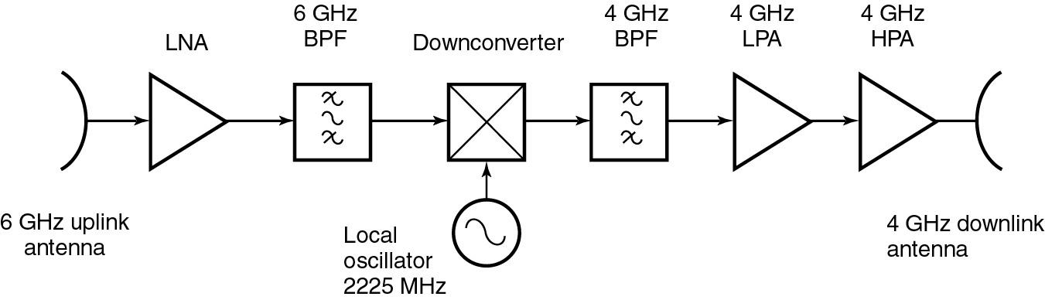

Figure 3.12 Simplified single conversion transponder (bent pipe) for 6/4 GHz band.

Transponders for use in the 14/11-GHz band normally employ a double frequency conversion scheme as shown in Figure 3.13.
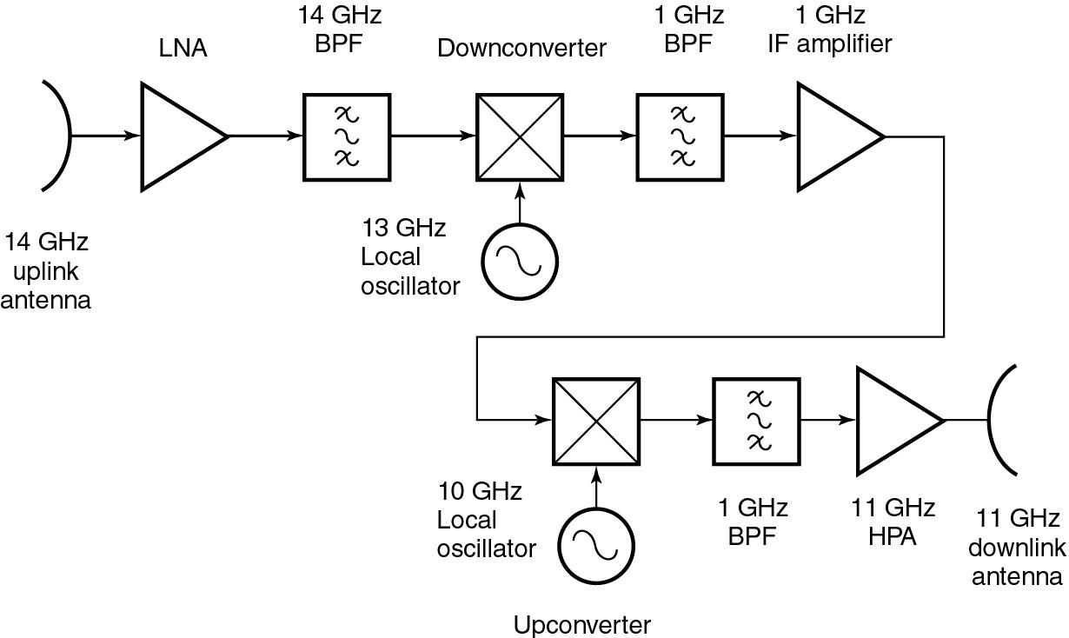

Figure 3.13 Simplified double conversion transponder (bent pipe) for 14/11 GHz band.

It is easier to make filters, amplifiers, and equalizers at an intermediate frequency (IF) such as 1100 -MHz than 14 or 11 GHz.

Stringent requirements are placed on the filters in transponders, since they must provide good rejection of unwanted frequencies such as intermodulation products, and very low amplitude and phase ripple in their passband.

Frequently a filter is followed by an equalizer to smooth out amplitude and phase variations in the passband.

Phase variation across the passband produces group delay distortion which is particularly troublesome with wideband FM signals and high-speed PSK signals.

A considerable increase in the communication capacity of a satellite is achieved by combining on-board processing with switched-beam technology.

A switched-beam satellite generates a narrow transmit beam for each earth station, and then transmits sequentially to each one using time division multiplexing (TDM) of the signals.

The narrow beam has to cover only one earth station, allowing the satellite transmit antenna to have a very high gain compared to a zone-coverage antenna.

A narrow scanning beam can also be used, or a combination of fixed data storage is required at the satellite since it communicates with only one earth station at a time.

The downlink, not uplink, usually limits the capacity of a transponder because of the low transmit power available from the satellite.

It is possible to conserve uplink bandwidth by using different modulation techniques on the uplink and downlink and by providing a baseband processor on the satellite.

A high level modulation such as 16 -QAM with four bits per symbol can be used on the link between the satellite and a large earth station to improve bandwidth efficiency.

This approach has been adopted in the Astrolink and Spaceway 30 / 20 GHz satellites.

Onboard processing may also be used to be used to advantage to switch between the uplink access technique (e.g., MF-TDMA) and the downlink access technique (e.g., TDM) so that small earth stations may access each other directly via the satellite.

A typical arrangement of the communication system for a satellite employing onboard processing is shown in Figure 3.14
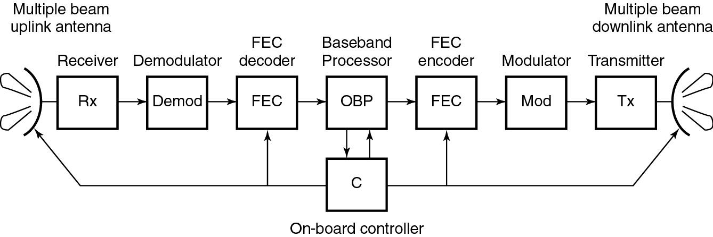

Figure 3.14 Onboard processing transponder.

- Satellite Antennas

Basic Antenna Types and Relationships

Four main types of antennas used on satellites:

- Wire antennas: monopoles and dipoles

- Horn antennas

- Reflector antennas

- Array antennas.

Wire antennas are used to provide omni-directional coverage mainly at VHF and UHF for the TT&C systems.

As most satellites are only a few wavelength long at VHF frequencies, it is difficult to get the required antenna patterns and there tend to be some orientations of satellite in which the gain for the TT&C system is reduced by nulls in the antenna pattern.

Typical satellite antenna coverage zones are shown in Figure 3.15.
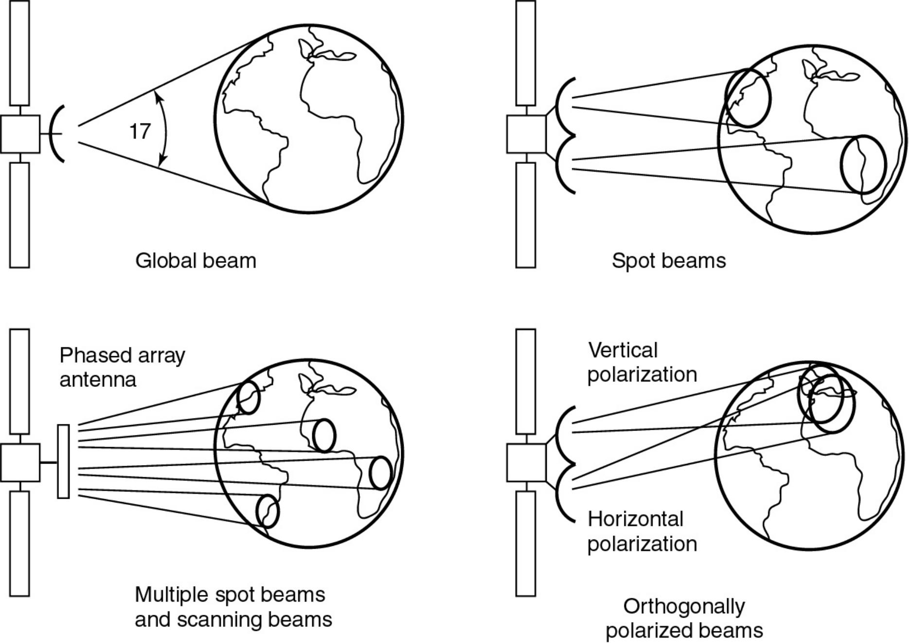

Figure 3.15 Typical satellite antenna patterns and coverage zones.

The antenna for the global beam is usually a waveguide horn.

Scanning beams and shaped beams require phased array antennas or reflector antennas with phased array feeds.

The pattern is specified by its 3 -dB beamwidth.

Figure 3.16 shows the contours of satellite transmit antenna gain expressed by the EIRP of the satellite antenna and transmitter.

In Figure 3.16 contours are in 1 dB steps, normalized to 0 dB at the center of the beam.
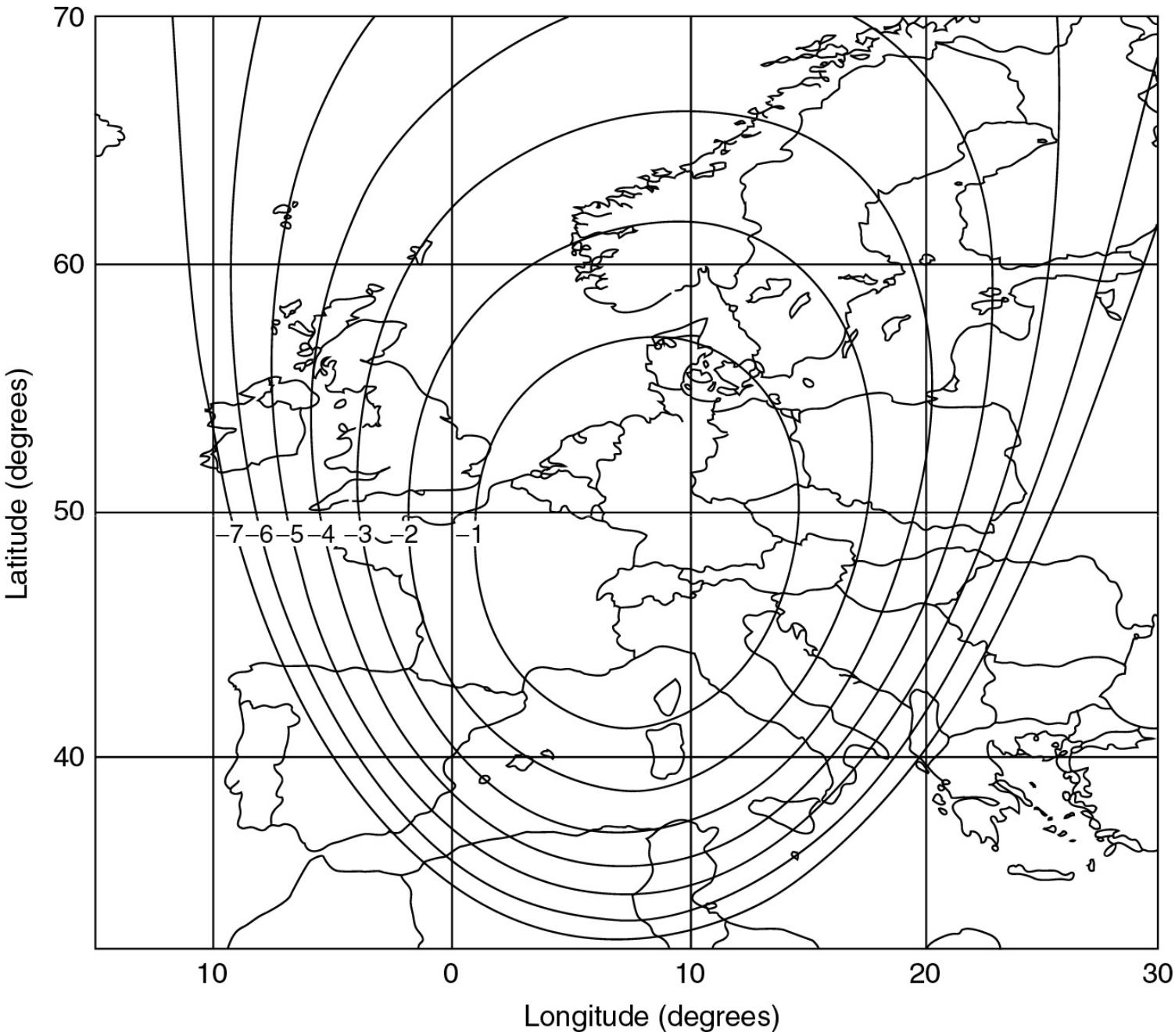

Figure 3.16 Typical coverage patterns for Intelsat satellites over the Atlantic Ocean.

To calculate the exact EIRP it is needed to know the location of the earth station relative to the satellite transmit antenna contour.

When the satellite transmit antenna contour is not known, the antenna gain in a given direction may be estimated if the antenna boresight (or beam axis direction) and its beamwidth are known.

Horn antennas are used for relatively wide beams like global beam at microwave frequencies.

A horn has an aperture of several wavelengths having good match between the waveguide and free space. Horns are also used as feeds for reflectors either singly or in clusters.

It is difficult to obtain gains much greater than 23 dB or beamwidths narrower than 10º with horn antennas.

Reflector antennas have one or more horns as feeds and provide a larger aperture than that can be achieved with a horn alone.

To obtain maximum gain it is designed to generate a plane wave in the aperture of the reflector.

This is achieved by choosing a reflector profile that has equal path lengths from the feed to the aperture such as a paraboloid with a feed at its focus.

In many satellite antennas, modified papaboloidal reflector profiles are used to tailor the beam pattern to a particular coverage zone.

The gain of an aperture antenna is given by
G ⁴ ^{A} |  | (3.1)
 | ²
where A is the area of the antenna aperture,
is the wavelength,
and is the aperture efficiency of the antenna.
is 65 to 80 % for horn antennas, 50 to 65 |  | % for reflector antennas with single feed, and lower value
for reflector antennas with shaped beams.
If the aperture is circular, as is often the case (3.1) is written as
 | D ² | (3.2)
G |  | (3.2)

where D is the diameter of the circular apertures in meters.

3 dB,2

3 dB ,1

The beamwidth of an antenna depends on the wavelength and aperture dimension.

By a rule of thumb for antennas with dimension D in a given plane, 3 -dB (or half-power) beamwidth in that plane is given by

3dB |  | 75 | degrees
 |  | D
where | D / |  | is the aperture dimension in wavelengths.

From (3.2) and (3,3), for antennas with 55%, antenna gain is approximated as

_{G} 30,000 ( _{3dB} )²

where _{3dB} is in degrees.

(3.3)

(3.4)

If the beam has different beamwidths in orthogonal planes, ( _{3dB} )² should be replaced by the product of

two 3 -dB beamwidths, .

Ex 3.6.1 (Global Beam Antenna)

DYI

Ex 3.6.2 (Regional Coverage Antenna)

DYI

Satellite Antenna in Practice

In an ideal satellite, there would be one antenna beam for each earth station, completely isolated from all other beams, for transmit and receive.

However, if two earth stations are 300 km apart on the earth’s surface and the satellite is on the geostationary orbit, their angular separation at the satellite is merely 0.5º .

For _{3dB} to be 0.5º , ^{D} must be 150, which requires an aperture diameter of 11.3 m at 4 GHz.

Antennas this large have been used on some satellites (for example, ATS-6 deployed 2.5 GHz, 10 -m diameter antenna).

However, at 20 GHZ, an antenna with ^{D} 150 is only 1.5 m wide, and such an antenna can readily be flown on a 30 / 20 GHz satellite.
A phase array feed is used to create many 0.5º beams which can be clustered to serve the coverage zone of

the satellite.

To provide a separate beam for each earth station, one antenna feed per earth station is required if multiple-feed antenna with single reflector is used. (See Figure )

As a compromise between one beam per station and one beam for all stations, many satellites use zone-coverage beams with orthogonal polarizations within the same beam.

Figure 3.3b shows a satellite that has four reflector antennas.

Each reflector is illuminated by a complex feed that provides the required beam shape to permit communication between earth stations within a given coverage zone.

Figure 3.17 shows the coverage zones provided by typical Intelsat satellite.
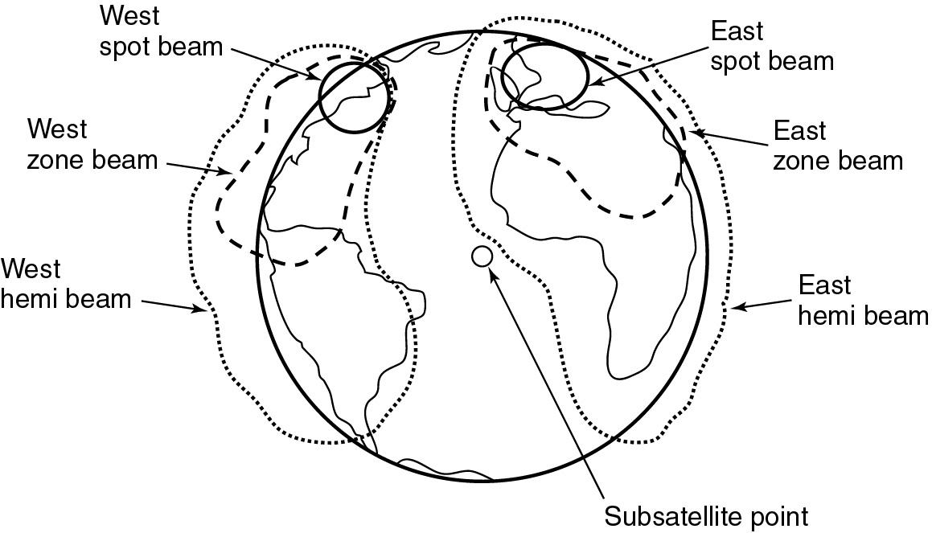

Figure 3.17 Contour plot of the spot beam of ESA’s OTS satellite projected onto the earth.

The largest reflector on the satellite transmits at 4 GHz to produce “peanut” shaped patterns for the zone beams, which are designed to concentrate the transmitted energy onto densely populated areas where much telephone traffic is generated.

The smaller antennas provide hemisphere transmit and receive beams, and 14/11 GHz spot beams.

Note that antenna beamwidth inversely proportional to the square of frequency.

In addition, horn antennas provide global beam coverage.

In many larger satellites, the antennas use offset paraboloidal reflectors with clusters of feeds to provide carefully controlled beam shapes.

The feeds are mounted on the body of the satellite, close to communication subsystems, and the reflector is mounted on a hinged arm.

Figure 3.18 shows an example of this design of antenna for the INTELSAT VI satellite.
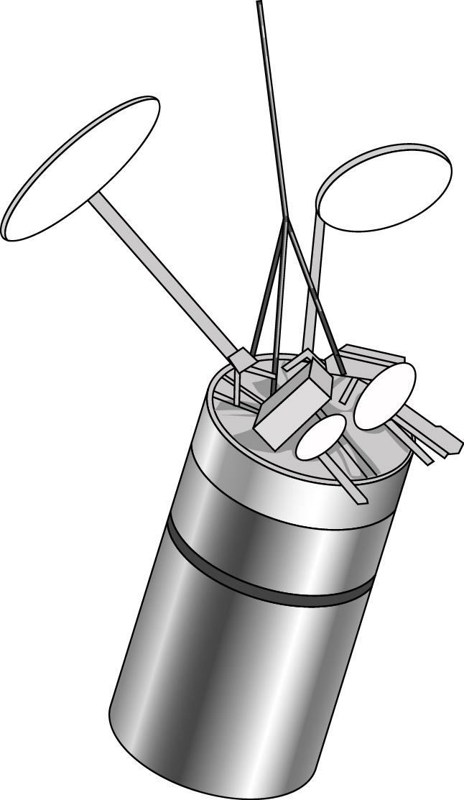

Figure 3.18 Intelsat VI satellite on station.

Wireless and Satellite Communications |  | Prof. Jae Hong Lee, SNU
Chapter 3. Satellite | - 79 - | 2nd Semester, 2010

Figure 3.19 shows the deployment sequence used for the 30 -ft antenna carried by ATS- 6: the antenna was built as a series of prtals that folded over each other to make a compact unit during launch, which then unfolded in orbit.
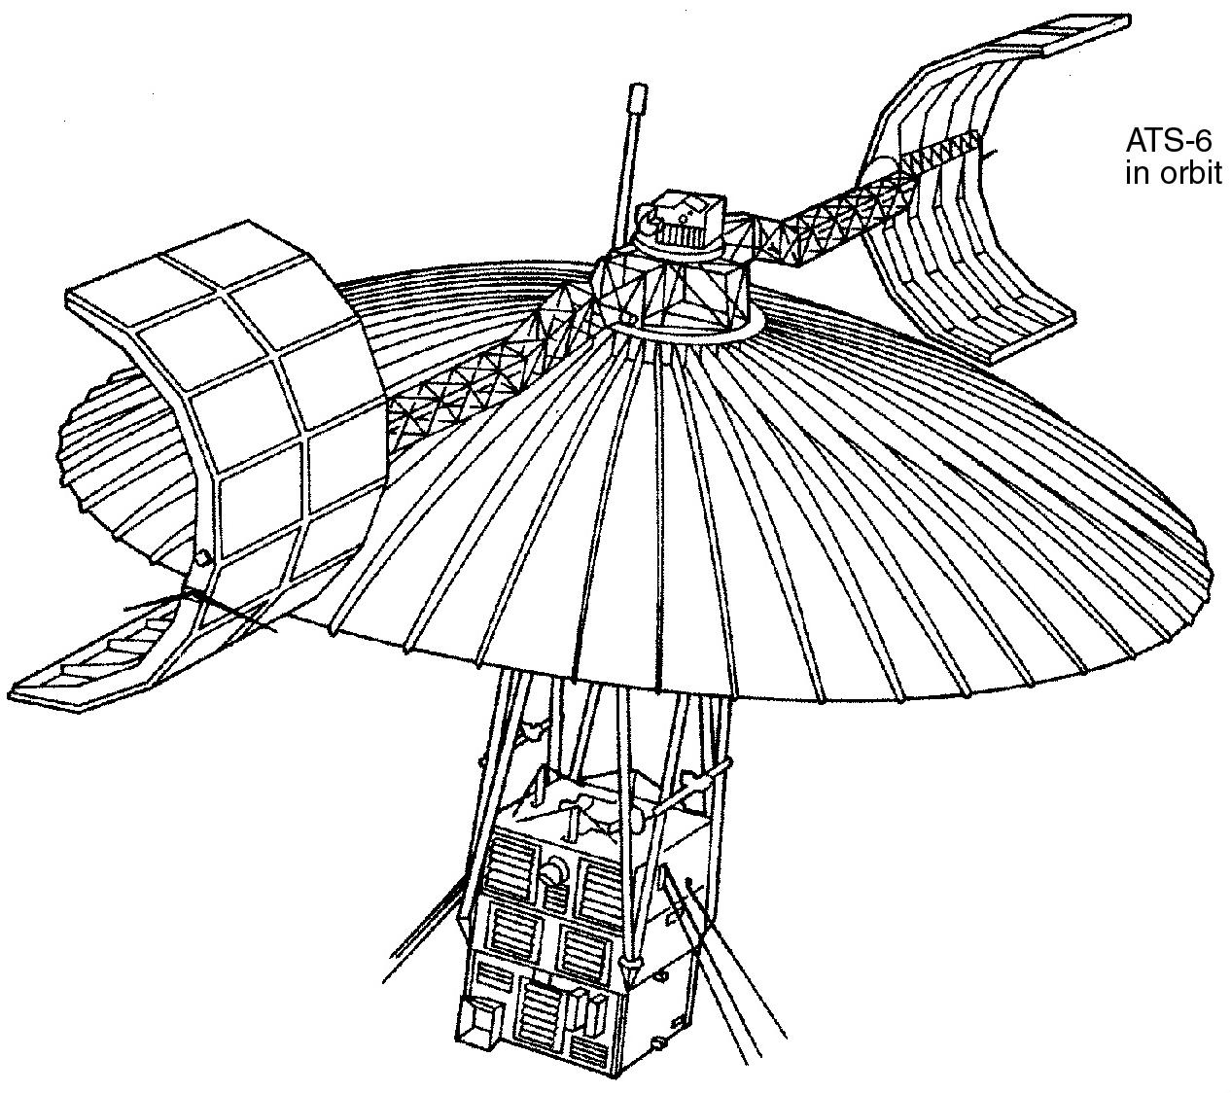
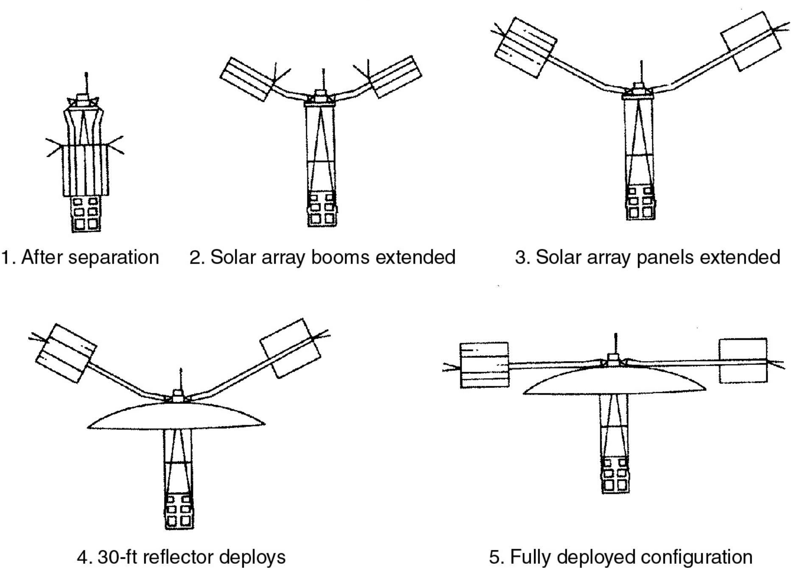

Figure 3.19 Deployment sequence of ATS- 6 10 -m antenna. (Courtesy of NASA.)

3.7 Equipment Reliability and Space Qualification

Once a satellite is in geostationary orbit there is little possibility of repairing components that fail or adding more fuel for staionkeeping.

To guarantee the reliability, two separate approaches are used: space qualification of every part of satellite to ensure its long life expectancy and redundancy of the most critical components to provide continued operation when one component fails.

Space qualification

A satellite on the geostationary orbit has in harsh environments: total vacuum, 1.4 kW/ m² of heat and light radiation from the sun, and temperature falling toward absolute zero in shadow.

Electronic equipment must be housed within the satellite and heated or cooled so that its temperature stays

within 0º to 75º C.

This requires a thermal control system that manages heat flow throughout a GEO satellite as the sun moves around once every 24 h.

Thermal problems are equally severe for a LEO satellite that moves from sunlight to shadow every 100 min.

Quality control or quality assurance is vital in building any equipment that is reliable.

When a satellite is designed, three prototype models are often built and tested: the mechanical model, thermal model, and electrical model.

The thermal model contains all the electronics packages and other components that must be maintained at the correct temperature.

Often, the thermal, vacuum, and vibration tests of the entire satellite is combined in a thermal vacuum chamber for a shake and bake test.

Reliability

We want to know the probability that the subsystem is still working after a given time period, and we need to provide redundant components or subsystems there the probability of a failure is too great to be accepted.

Components for satellite are selected only after extensive testing.

The reliability of a component can be expressed in terms of the probability of a failure after time t , P_{F} (t ) .

For most electronic equipments, probability of a failure is higher at the beginning of life the burn-in period than at some alter time.

As the component ages, failure becomes more likely, leading to the bathtub curve shown in Figure 3.20
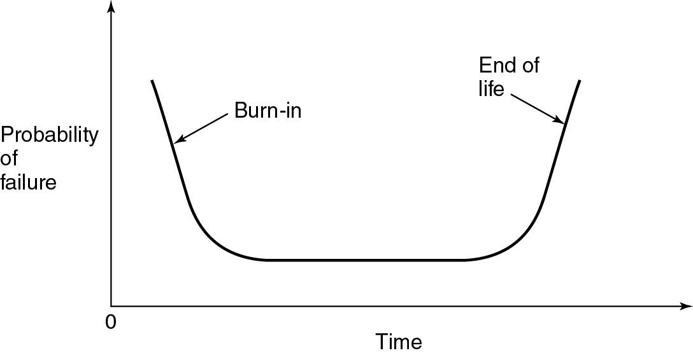

Figure 3.20 Bathtub curve for probability of failure.

The initial period of reduced reliability can be eliminated by a burn-in period before a component is installed in the satellite.

Semiconductors and integrated circuits that are required to have high reliability are subject to burn-in periods from 100 to 1000 hours, often at a high temperature and excess voltages to induce failures in any suspected devices.

The reliability of a device or subsytem is defined as

_{R} _{(t)} ^{N} s ^{(t)} ^{N}0

Number of surviving components at time t . Number of components of test period

The number of components that failed in time t is given by

N _{f} (t ) N ₀ N _{s} (t) .

(3.5)

(3.6)

Suppose that the i th device fails after time t_{i} .

Then the mean time before failure (MTBF) is given by MTBF m
₁ ^{N}0

_{N0} _{i} ₁ ^{t}i .

Assume that the average failure rate is constant and let it be defined by

Number of failures in a given time . Number of surviving componrnts

Then, the average failure rate is given by

 | 1 |  |  |  |  |  |  | N _{f} (t)
 | N _{s} (t ) |  |  |  |  |  |  |  |  | t
 | 1 |  |  |  |  |  |  |  |  | dN _{f} (t)
 |  | N _{s} (t ) |  |  |  |  |  |  |  | dt
 | 1 |  |  |  |  |  |  |  | .
 |  | MTBF

(3.7)

(3.8)

As | dN _{f} (t ) |  |  | is the negative of the rate of survival |  | dN _{s} (t) | , so we re-define the average failure rate | as
As |  | dt |  |  |  | dt | , so we re-define the average failure rate | as
 |  | 1 | dN _{s} (t) |  | . |  |  | (3.9)
 |  | N _{s} (t ) |  | dt | . |  |  | (3.9)

From (3.5) and (3.9), it becomes

¹ ^{d} N ₀ R (t) N ₀ R (t ) dt

1 dR (t ) . R(t ) dt

A solution of (3.9) for R(t) is obtained as

R(t ) e ^{t} .

(3.10)

(3.11)

Thus the reliability of a device decreases exponentially with time, with zero reliability after infinite time, that is, certain failure.

However, the end of useful life is usually taken to be time t |  |  | l | at which R(t) falls to 0.37 ( e ¹) , which is
when
t_{l} | 1
m
( MTTF) . |  |  |  | (3.12)

The probability of device failing has an exponential relationship with the MTBF and is represented by the right-hand end of the bathtub curve.

Redundancy

In a satellite, many devices, each with a different MTTF, are used, and failure of one device may cause catastrophic failure of a complete subsystem.

If redundant devices are incorporated, the subsystem can continue to function correctly.

Consider three different situations shown in Figure 3.21: series connection, parallel connection, series/parallel connection, and switched connection.
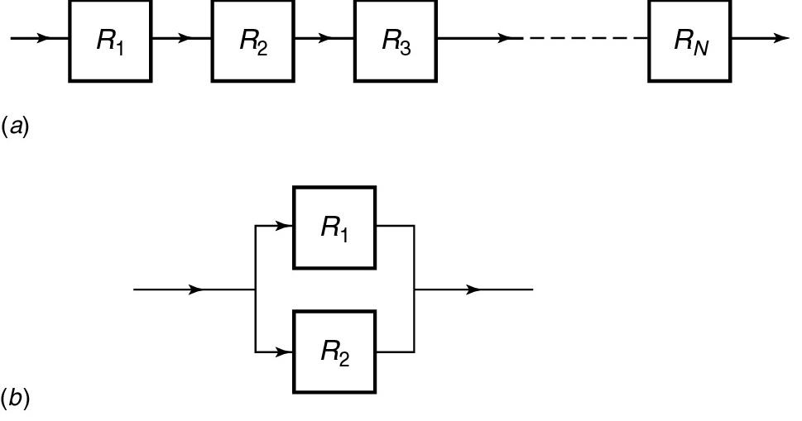

Figure 3.21 Redundancy connections. (a) Series connection, (b) Parallel connection. (cont’d)

The switched connection arrangement shown in Figure 3.21d is also called ring redundancy since any component can be switched in for any other.
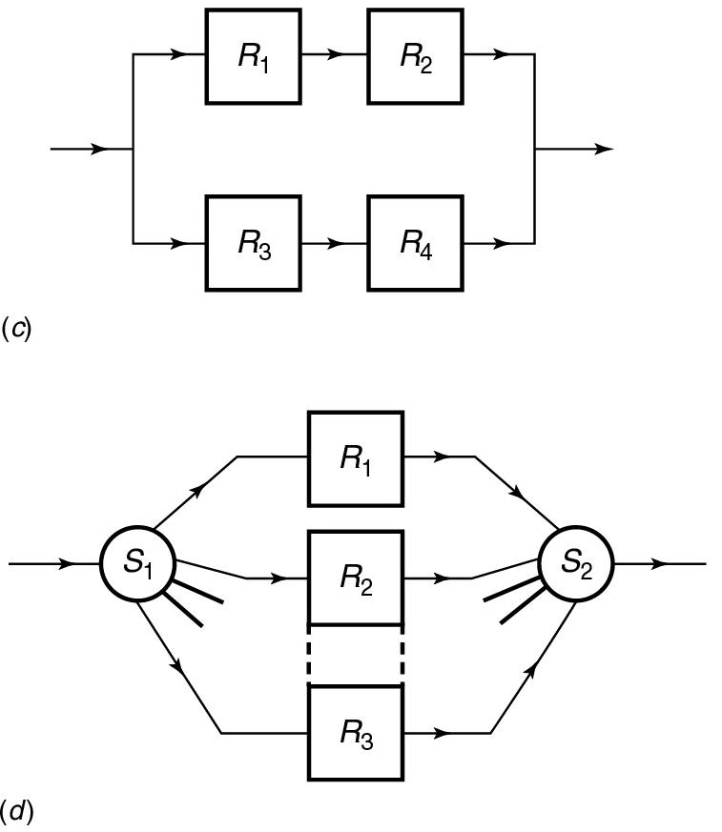

Figure 3.21 Redundancy connections. (c) Series/parallel connection, (d) Switched connection.

As example of parallel redundancy for the HPA of 6 / 4 GHz bent pipe transponder is shown in Figure

3.22.

If one TWTA fails, the other is switched on either automatically, or by command from the earth station.

The TWTA is a thermionic device, with heated cathode and high-voltage power supplies.

Like other thermionic devices, they have a relatively short MTBF.

The parallel connection of two TWTs, as shown in Figure 3.22, raises the reliability of the amplifier.
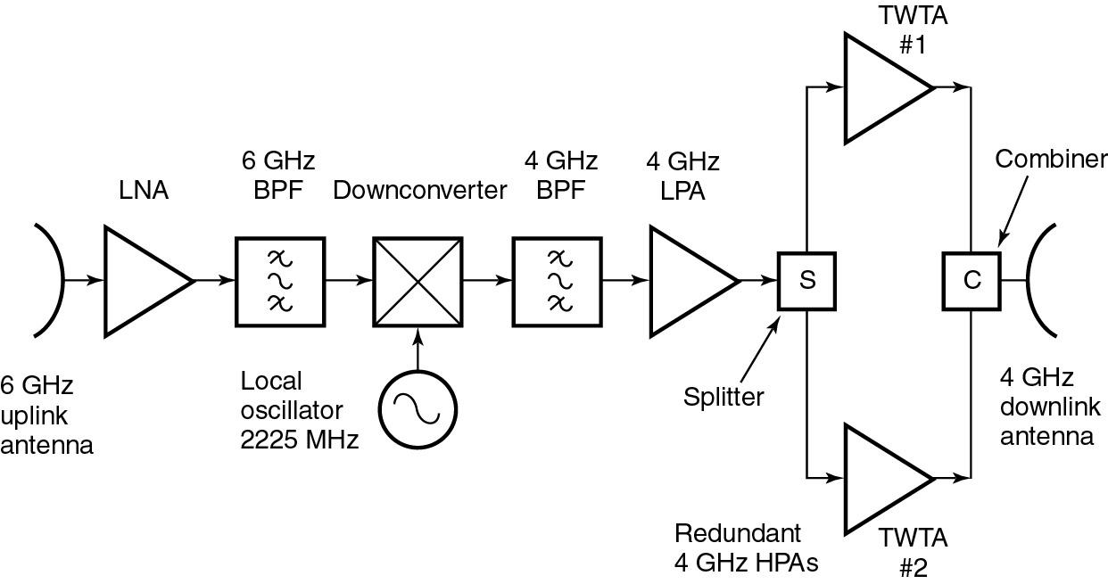

Figure 3.22 Redundant W/TA configuration in HPA of a 6/4 GHz bent pipe transponder.

